State Street
Global Markets

Proof of Concept Plan

Author: Michael Forristall
Date Created: June 3, 2008
Version: 1.0

- Opportunity Overview

  - Project Description and Scope

Global Markets both sends and receives files containing both currency and security trade instructions from their clients containing which needs to be processed as efficiently as possible. The difficulty is that some of the data being received by the environment (using Tumbleweed) is in formats that the existing infrastructure has difficulty handling. The data being received is contained in both flat files that contain structured data as well as flat files that contain SWIFT transactions. The flat file data must be converted to the State Street internal file format, SI XML, before being placed onto the OMS MQ message bus for processing. The flat file containing SWIFT transactions must be processed by extracting the individual transactions and then place each one onto the existing SWIFT MQ message bus for processing.

Outbound data requires

additional data from an OMS Oracle database from which data is extracted to enrich the outgoing flat file data. This data file is then transformed to multiple formats depending on the client requirements.

Global Markets is undertaking a project to re-architect the document translation capabilities of their existing file transfer environment. As part of the evaluation process Sterling Commerce has been asked to participate in a proof-of-concept (POC) to evaluate our capabilities to receive files in multiple formats and successfully convert those documents to the required inbound file formats. The POC will also evaluate our capabilities to handle outbound files that must be enriched from an existing database and then converted to a specific client requested flat file format prior to submitting the file for delivery to the client.

Followings are the key characteristics to be measured for this POC:

- Reliability/Availability – System behavior if a component goes down
- File Transformation Capabilities – Pick up files from a shared local hard drive (or available SAN) which will contain data in one of two flat file formats. These document must be successfully transformed to either the internal flat file format (SI XML) or, if the flat file contains SWIFT transactions, the files must be successfully rebuilt as a SWIFT message.
- Depending on the file format the document must be successfully placed onto the appropriate MQ queue. Flat file formats that are in the SI XML format must be successfully placed onto the OMS MQ queue. Flat files that have been converted to SWIFT messages must be successfully placed onto the SWIFT MQ queue.
- If any of the translation steps or the placing of the files onto the appropriate MQ queue is unsuccessful an appropriate alert must be generated.

Due to the platform limitations of the hardware available for this POC a full Performance test will not be able to be included in the POC.

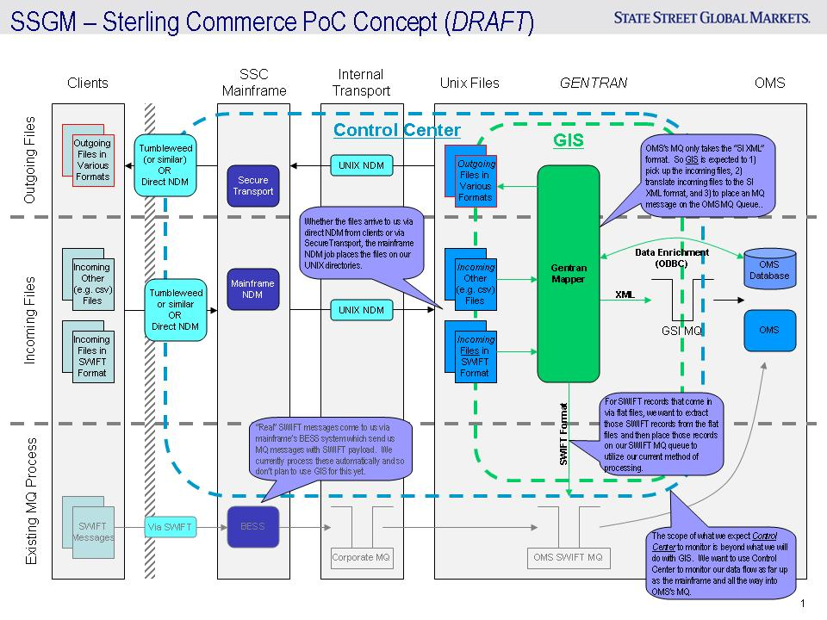
This page is for reference only and will be deleted from final version of document. This image shows the document flow within SSGM and where each of the files – either received or sent – and how the files interact with MQ.

- POC Project Objectives

  - POC Objectives

The POC is designed to measure reliability of the system and the architecture capabilities for providing high availability of the system. The POC will cover the following scenario:

Scenario | Value of POC Execution to Production Environment Build-out | Scenario Description (refer to Figure 2 in section 3.2.2)
High Availability test | Provides a functional test for the solution to provide high availability if one of the two GIS servers is taken down. | In this scenario a standard set of incoming files is placed in the inbound watch directory (shared SAN or mounted drive) for processing. While GIS is processing these files one of the two GIS servers will be taken offline (stopping of the GIS Windows Services) to show that the remaining GIS server will continue processing the files.
Process inbound FX Connect files | Provides a functional test for the solution to provide translation capabilities for incoming files which are in a FX Connect flat file format | In this scenario a set of FX Connect files will be placed into the inbound watch directory (shared SAN or mounted drive) for processing. GIS will pick up these files and run them through the translator to convert them to the internal SI XML format and place these files onto the OMS MQ queue
Process inbound SWIFT files | Provides a functional test for the solution to provide translation capabilities for incoming files which contain SWIFT transactions in a flat file format | In this scenario a set of SWIFT transactions in flat file format will be placed into the inbound watch directory (shared SAN or mounted drive) for processing. GIS will pick up these files and run them through the translator to convert them to SWIFT messages and place these transactions onto the SWIFT MQ queue
Process outbound files | Provides a functional test for the solution to provide translation capabilities for outbound files from the OMS Database to a flat file format needed to send to the client | In this scenario we will read data from the OMS Database to extract data on a scheduled basis. The query will return data which will be written to a flat file and placed into the outbound directory
Alerting | Provides a functional test for the solution to provide detection and alerting capabilities to capture when GIS Server outages and processing errors occur | In this scenario the use of Sterling Control Center will be used to monitor the status of the GIS Server Windows Services to determine if the system is running correctly and also detect if any of the translation service business processes fail.

These scenarios will use grouped collections of the different inbound file formats to allow for concentrated testing of the translation capability for each of the document formats required. The inbound and outbound watch directories can be either shared disk (SAN) or a shared mounted drive so that both nodes of the GIS cluster have access to them. The high availability test will use the 2 node GIS cluster to validate the HA capability of the solution. These POC scenarios do not require integration to either front-end or back-end systems. Testing will be performed by Sterling representatives under the observation of State Street representatives. Sterling Commerce will provide Sterling software installation and configuration expertise.

    - High Availability Test Scenario
This test scenario is expected to include the following dimensions modeled after the current and future production system usage for the File Management platform:
- A two-node GIS cluster of Windows 2003 Servers
- A mix of incoming files containing sample data in FX Connect and SWIFT transactions in flat file formats

The performance of the solution will be based on the following:
- A failover test to determine solution behavior with the removal of:
  - 1 GIS Server from the cluster

    - Process Inbound FX Connect Files Scenario
This test scenario is expected to include the following dimensions modeled after the current and future production system usage for the File Management platform:
- A set of flat files containing FX Connect formatted data

The performance of the solution will be based on the following:
- The ability to successfully retrieve files from the inbound watched directory used to initiate the translation process
- Successfully translate the incoming FX Connect format data into the internal data format used by State Street Global Markets - IS XML
- Successfully submit the file to the OMS MQ message bus

    - Process Inbound SWIFT Files Scenario
This test scenario is expected to include the following dimensions modeled after the current and future production system usage for the File Management platform:
  - A set of flat files containing SWIFT transaction data

The performance of the solution will be based on the following:
- The ability to successfully retrieve files from the inbound watched directory used to initiate the translation process
- Successfully extract the SWIFT transactions from the incoming flat file
- Successfully submit each of the transactions onto the SWIFT MQ message bus

    - Process Outbound Files Scenario
This test scenario is expected to include the following dimensions modeled after the current and future production system usage for the File Management platform:
  - Access of the OMS Database for extracting outbound data

The performance of the solution will be based on the following:
- The ability to successfully schedule the retrieval of data from the OMS Database
- Successfully writing the data returned from the SQL query used to create flat files in the Outbound directory

    - Alert on Server availability and Translation process completion
This test scenario is expected to include the following dimensions modeled after the current and future production system usage for the File Management platform:
  - A full installation of GIS with running Translation processes
  - A full installation of Sterling Control Center

  - POC Critical Success Factors

Success Scenario | Success Criteria | Comments | Prospect Sign-off
Install GIS
High Availability test | The success of this test will be the successful continuation of payload processing when solution components are shut down and restarted | Test will be run once with the 2 node GIS cluster
Process inbound FX Connect files | The success for this test will be the successful transformation of the incoming FX Connect formatted data files into IS XML formatted data and submitting that data file on to the OMS MQ message bus | Test will be run once using data files supplied by State Street
Process inbound SWIFT files | The success for this test will be the successful transformation of the incoming data files into SWIFT messages and submitting that data file on to the SWIFT MQ message bus | Test will be run once using data files supplied by State Street
Process outbound files | The success for this test will be the successful addition of data from the OMS database to the internal IS XML formatted data, successful transformation of the data into FX Connect format data files and delivery of those data file to an Outbound directory for viewing | Test will be run once using data supplied by State Street
Alerting | The success for this test will be the successful notification of both a GIS Server down and notification of a failed Translation process within GIS | Test will be run once using data files supplied by State Street and with Translation processes already created for previous scenarios

- POC Requirements

  - Business Process Flows

This POC will contain a number of business process for translating each of the inbound file formats as well as the outbound file format. There will also be a scheduled business process that will scan the Inbound watched file directory. This business process will trigger the translation business process once an inbound file is found in the watched directory.

The FX Connect inbound business process will implement a map that will translate the incoming FX Connect formatted data into the State Street Global Market’s internal data format – IS XML. This process will also take the resulting data and place it onto the OMS MQ message bus for delivery.

The SWIFT inbound business process will implement a map that will translate the flat file data formats into SWIFT transactions and then submit the transactions to the SWIFT MQ message bus.

The outbound business process will implement a map that will enhance the data from a lookup from the OMS Database and then another map that will transform the resulting data into the outbound FX Connect formatted data file. The process will then place the resulting data file into the Outbound file directory.

    - Business Process Diagrams
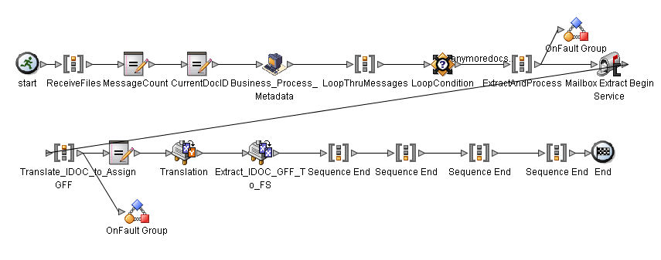
The above is a sample of the types of business process that we will need to create.

  - Overall POC Schematic Diagrams and Server requirements

The topologies below list the hardware and software requirements for this POC.

    - GIS Hardware Installation Topology

The following topology (Figure 1) describes the hardware requirements for this POC. This hardware will be used for all of the functional tests described above in section 2.1.

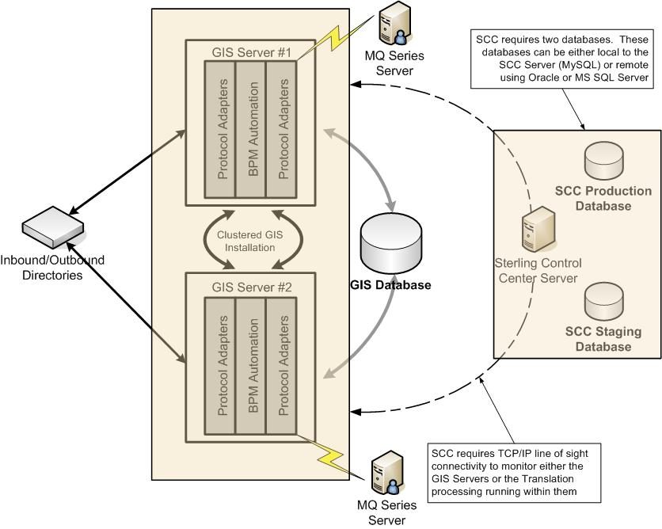

Figure 1 GIS – SCC Hardware Topology

- Sterling Software:
  - GIS 4.3
  - SCC 4.2

- GIS Instance requirements:
  - 2 Windows 2003 Server Enterprise Edition Servers
  - Server 1 has 1.5 GB of RAM running AMD 2.60 GHz processor
  - Server 2 has 3.7 GB of RAM running Intel 2.80 GHz processor
  - JVM – Sun JDK 1.5.0_11
  - JCE – Sun jce_policy-1_5_0.zip

- Sterling Control Center requirements:
  - 1 Windows 2003 Server Enterprise Edition Server
  - Server has 3.7 GB or RAM running Intel 2.80 GHZ processor

- GIS Instance Database (a separate database server is required):
  - Oracle® Database 9i Standard and Enterprise Editions, Release 2 (9.2.0.7 non-RAC or higher within version 9.2.X.X)
  - Oracle Database Settings:
  - Character Set "UTF8"
  - Configure the INIT<INSTANCE_NAME>.ORA file for Oracle as follows:
  - open_cursors= <set to appropriate value> (For example, the minimum value for WebLogic equals number of threads (across all application servers) + (connection pool size X prepared statement pool size).
  - cursor_sharing=exact
  - compatible=<10.2.0.1>
  - timed_statistics=true
  - db_block_size=8192
  - optimizer_mode=CHOOSE

Oracle Database Privileges - Unless specifically stated for a given task, Gentran Integration Suite user does not require database administrator (DBA) privileges. The following are some of the basic privileges that are given to Gentran Integration Suite administrative user who is involved in creating and modifying the Oracle database:

- ALTER SESSION
- CREATE PROCEDURE
- CREATE SEQUENCE
- CREATE SESSION
- CREATE SYNONYM
- CREATE TABLE
- CREATE VIEW
- EXECUTE ANY PROCEDURE
- INSERT ANY TABLE
- UPDATE ANY TABLE
- SELECT ANY TABLE

The following are some of the basic privileges given to the application user whose involvement is restricted just to running the application:

- ALTER SESSION
- EXECUTE ANY PROCEDURE
- INSERT ANY TABLE
- UPDATE ANY TABLE
- SELECT ANY TABLE

JDBC Driver for Oracle database:
- Oracle JDBC Driver - 10.2.0.2 (ojdbc14.jar)

Sterling Control Center database:
Sterling Control Center requires two databases (a production and staging database). SCC comes with MySQL which can be installed on the server with the SCC Engine or these databases can be remote databases (Oracle 9i is supported). Requirements for both are below.
- Option 1: MySQL Database
  - MySQL 5.0 is included with the SCC installation files which can be installed on the same server as the SCC engine
- Option 2: Oracle 9i v.9.2.01 or 10g database
  - Oracle JDBC Driver – classes12.zip (Oracle 9i) or ojdbc14.jar (Oracle 10g)

GIS - SCC Software Installation Topology

The following topology (Figure 2) describes the software installation for this POC. The GIS, SCC and Oracle installations will be used for all of the scenarios.

Sterling will use a State Street supplied Oracle database model for GIS for this POC. The data stored in this database includes:
- GIS configuration information
- GIS asset configuration
- GIS process state information

Sterling will use either the Sterling supplied MySQL 5.0 database or a State Street supplied Oracle database model for SCC for this POC. The data stored in this database includes:
- SCC normalized data from managed servers
  - Production database contains active, short-term data
  - Staging database contains historical, long-term data

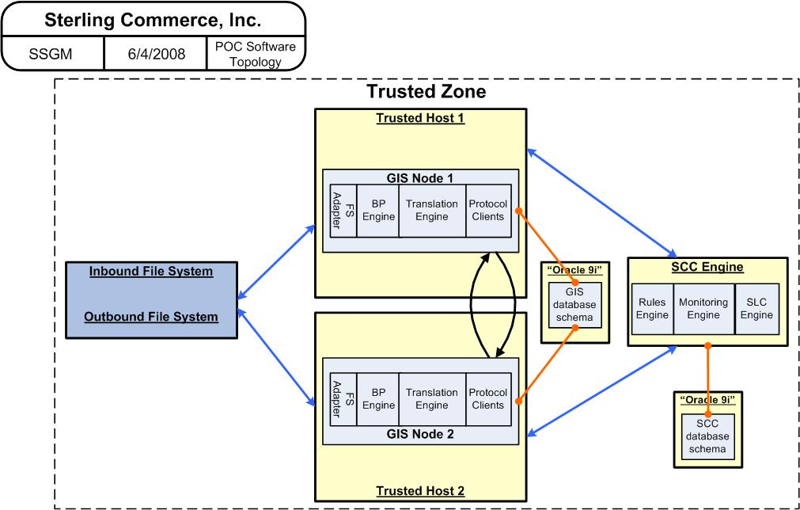

Figure 2 GIS – SCC Software Topology

- Detailed Interface Information

The following are the data formats, samples and elements that need to be mapped.

- Source and target data formats – Source documents FX Connect and flat file containing SWIFT messages and formats. Target document is the SI XML format described by State Street Global Markets
- Sample inbound documents – 54x flat file format and SWIFT MT 380 documents attached at the end of this section
- Sample internal documents – SI XML format document used internally at State Street Global Markets attached at the end of this section
- Mapping and business rules for each interface – Maps required are X12 to GFF and IDOC to GFF

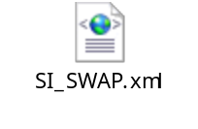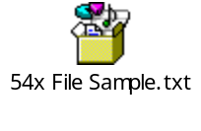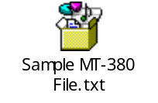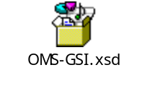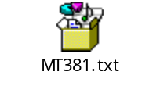

Failover Requirements for GIS Installation

Failover capabilities will be tested by disabling a GIS node during failover test to see how the system reacts when an individual GIS node is taken down. GIS will be installed with a 2-node cluster configuration as part of the base installation for this POC and will be used for this test.

Sterling Installation Requirements

- Can Sterling connect their laptops to the State Street Global Markets network?

Individual Hardware Specifications: The following section should be used as a template for State Street Global Markets to identify the hardware needed by Sterling Commerce.

Machine type
Machine name/IP address
OS and version
OS Patch level
CPU type/speed/number
Total Disk space
Disk space for POC
Total memory
Memory available for POC
CD drive accessible
System Admin contact
JVM installed
UserID/Password
Other applications running

Sterling Files and Documents for Onsite Use

The POC team will create the following files to facilitate a quick start to the POC when our team arrives onsite. These documents, maps, and business processes will be created at Sterling Commerce and follow standard practices:
- Pre-built standard maps for translation between inbound, outbound and internal document formats
- Pre-built business processes
- Documents containing performance tuning parameters which will be performed while onsite:
  - Clustering tuning parameters
  - Database tuning parameters
- Deployment scripts to install GIS and required database tables
- Cleanup scripts to clear out results of prior tests to return system to a consistent base level
- Scripts to capture reporting details of tests

POC Timeline and State Street Global Markets Resources required

The following timeline is a high-level overview of the POC and the resources we will need from State Street Global Markets to successfully configure and complete this POC.
- June 13th – Completion of Sterling Installation Requirements Templates
- June 23rd – June 24th: Onsite preparation (GIS installations, run basic dataflow through to validate system connectivity
  - DBA (create databases and adjust database configurations)
  - Network expert (firewall port authorizations)
  - Security expert
  - Hardware system administrator
  - POC Project manager
  - POC Technical lead
- June 25th – June 27th: Onsite execution of the inbound and outbound file translation
  - DBA (create databases and adjust database configurations)
  - Network expert (firewall port authorizations)
  - Security expert
  - Hardware system administrator
  - POC Project manager
  - POC Technical lead

Work Environment

The POC team will require a centralized work space where they can work together. Establishing a project room would be most desirable. The room should include:

- Client machines with network connections
- Telephone
- White board
- If internet access is not possible from the POC network then dial up must be available.
- Description of the normal working hours for the site.

Understanding of POC Scope

Both Sterling Commerce and State Street Global Markets agree to the scope of the POC as defined in this document. Any changes to this scope must be agreed to in writing by both Sterling Commerce and State Street Global Markets.

Name | Michael Forristall | Signature
Title | Sr. Solutions Engineer | Date
Company | Sterling Commerce

Name | Dan Luongo | Signature
Title | Dir, Sales Engineering | Date
Company | Sterling Commerce

Name |  | Signature
Title |  | Date
Company | JP Morgan Chase

POC Completion

Sterling Commerce has successfully completed the POC as defined in this document. All Critical Success Factors and POC Objectives have been met, either by demonstration or adequate explanation.

Name |  | Signature
Title |  | Date
Company | State Street Global Markets

